2020 SNJR/SNGC Membership Application

If you ride as a Non-Member, you will not be eligible or begin accumulating YEAR-END POINTS until you change your status to a member and pay the membership fee. You will however be eligible for day end points and awards.
2020 SNGC Gymkhana Schedule + Monthly revolving event.
PLAY DAY APRIL 26th – FUN EVENTS
MAY 9th –QUEEN/PRINCESS CONTEST
MAY 10TH - revolving event is 2 Barrel Cow Horse
MAY 31st – revolving event is Big M
JULY 12th – revolving event is Turn N Burn
AUGUST 9th – revolving event is Double Bow Tie
AUGUST 30TH - revolving event is Cat’s Cradle
SEPTEMBER 27th – revolving event is Streaking poles
OCTOBER 4th –MAKE-UP DAY IF NEEDED
SNJR FUNDRAISER JACKPOT JUNE 25th
SNJR JUNE 26TH

PLAY DAY APRIL 26TH SIGN UP 8:30 START10:00am **Weather Permitting
All GYMKHANA’S start 9am - summer months may begin 1 hour early
Pre entry at snjrandsngc@gmail.com

Age Groups

AGE AS OF JANUARY 1ST

7 & Under * 8 to 10 * 11 to 13 * 14 to17 * 18 & Over

Point events

BARRELS, POLES, BI-RANGLE, FIGURE 8, REVOLVING.

Non-point events

Goat un-decorating & Goat tying

GENERAL INFORMATION

Memberships are good for one year (Memberships start on the 3rd week of January and end the following 3rd week of January).

Monthly meetings are held on the second Wednesday of each month at the Round table in Reno: 185 Del Monte Pkwy, Reno. They will begin promptly at 6:00 pm. Your opinions, suggestions and comments are important. Make it a point to attend the monthly meetings.
INDEX

2020 Officers & Directors………………………………………………………………pg 3
Membership Overview………………………………………………………………….pg 4
Volunteer Overview……………………………………………………..……………pg 5-8
Volunteer Point duty Overview.…………………………………………………..…pg 9
Rules…………………………………………………………………………….…….pg 9-14
General rules……………………….pg 10-13
Points………………………………..pg 13-14
Awards……...................................pg 14-15
Classes……………………………...pg 14
Jackpot payout……………………..pg 16

Patterns……………………………………………………………………………….pg 17-24
Check list for forms to be turned in…………………………………………………pg 25

FORMS……………………………………………………………………………….pg 26-31
Membership…………………………………………………………………………..pg 20-21
Individual & Non-competing……….pg 26
Family………………………………..pg 27
Point horse………………………………….pg 28
Release……………………………………...pg 29-30
Rules Received……………………………..pg 31
Raffle…………………………………………pg 32

2020 Officers

Allison Hall-Galloway, President
Joya Machabee, Vice President
Karen Sommers, Secretary
Amber Koch, Treasurer

2020 Directors

Janet Bierman Brenda Hewitt
Lisa Jones Tamara Powers
Shelly Willsie Tracy Bryant
Anita Smith Lindsay Wicks

We have listed on PAGE 25 the forms which need to be returned

MEMBERSHIP 2020
The Sierra Nevada Junior Rodeo and Gymkhana Club
Offer (5) Different Types of Memberships.
Minor children must have a family membership.
YOU CAN NOT HAVE MORE THAN ONE MEMBERSHIP AND ONLY ONE POINT HORSE per PERSON

General Individual - $75 Must be 18-years or older
PLUS 15 raffle ticket sales or donation of equivalent value and minimum 4 nights selling programs or $100.00 sponsor/donation for each night missed at Reno Rodeo selling programs
This type of membership is for one individual who is 18-years of age (as of Jan 1^{st,}) or older and will be participating. This membership requires a mandatory amount of volunteer/fundraising duties for the Junior Rodeo/Gymkhana season. See “Volunteer/Fundraising” portion of this membership package for details. Points will begin to accumulate after membership fee is paid. This membership has the right to vote.

General Family - $150.00
PLUS 25 raffle ticket sales or donation of equivalent value and minimum 4 nights selling programs or $100.00 sponsor/donation for each night missed a Reno Rodeo selling programs
(Family means IMMEDIATE family in the same household, and UNDER 18-years of age). This type of membership is for family. This membership requires a mandatory amount of volunteer/fundraising duties for the Junior Rodeo/Gymkhana season. See “Volunteer/Fundraising” portion of this membership package for details. Points will begin to accumulate after membership fee is paid. This membership has the right to vote.

Individual Associate - $350
PLUS 2 nights selling programs or $100.00 sponsor/donation for each night missed at Reno Rodeo selling programs or $100.00 sponsor/donation for each night missed at Reno Rodeo selling programs
This type of membership is for one individual who is 18-years of age (as of Jan1st) or older and will be participating, and DOESN’T accumulate volunteer points. They DO NOT want to volunteer time at regular events . This membership also gives up the right to vote, however 2 nights selling programs at Reno rodeo is required for end of year awards.

Family Associate - $525
PLUS 2 nights selling programs or $100.00 sponsor/donation for each night missed at Reno Rodeo selling programs
(Family means IMMEDIATE family in the same household) This type of membership is for family. If two or more people in the family will be competing, and DO NOT want to volunteer any time this is the membership you would choose. This membership gives up the right to vote, however 2 nights selling programs at Reno Rodeo is required for end of year awards.

General non-Competing $50
PLUS 10 raffle ticket sales or donation of equivalent value and 4 nights selling programs or $100.00 sponsor/donation for each night missed at Reno Rodeo selling programs
This membership is for someone who would like to be a part of the club but does not compete. This membership requires a mandatory amount of volunteer/fundraising duties for the Junior Rodeo/Gymkhana season.

This club relies on the support of its members. Volunteers run all aspects of this Club. Though there are some special circumstances in which individuals/families are unable to volunteer, we urge you to consider the cost savings in your decision and keep in mind, volunteer time is not just immediate family…Aunts, Uncles, Brothers, Sisters, Grandparents, Neighbors and Friends can perform volunteer time. (See Volunteer section for further explanation)

Volunteering

Volunteers run the SNGC and Junior Rodeo. We are a non-profit organization that relies on the help of its members and their families and friends. We rely on you, our members, for success.

The type of membership you have chosen determines the amount of volunteer points you are required to earn in order to be eligible for year-end awards and voting privileges within the club. We have included a volunteer sheet as well as an explanation of each job so you can decide which volunteer position is best for you.

Each duty is assigned “Volunteer Points”. This is a way for the directors to keep track of who has done their volunteer responsibilities. Your volunteer time will be posted on the website so you can check after each gymkhana to confirm your time was noted. Please contact a director if you find any discrepancies. If a problem arises, and you cannot do your duty, it is your responsibility to contact a director so she/he can get your duty covered. Also, anyone can fulfill the volunteer obligations on your behalf. For instance, your husband, mother, next-door neighbor, grown child can do your duty for you. They must make sure a director knows which member they are representing. Please read the 2020 rules for more information on this subject.

SNJR & SNGC rely on fundraising in order to provide quality prizes at Junior Rodeo and year-end awards banquet. Some of those fundraising events are

Reno Rodeo Program Sales
50/50 raffle ticket sales
Silent Auctions
Raffle Donations
Sponsors and Donors
Jackpots

Please read the 2020 rules volunteer overview and read the descriptions to help you select a volunteer duty you would like to do. Please take your volunteer duties seriously. We need your help to make this year a success. If you have any questions, please do not hesitate to contact any director for further explanation.
A list of open volunteer positions will be provided via Facebook and email – watch for notifications a week prior to any event.

Volunteer Duty Overview

These overviews are to help you find a volunteer position that will be enjoyable. Each volunteer position is assigned volunteer points. If you have any questions or need the volunteer position explained more thoroughly, please do not hesitate to contact and Director. Thank you for your help. You are the heart of this club!. A volunteer position that takes most of the day is worth 10 points partial day earns 5 points is the general guide to volunteer points

Gates: (3 people needed)
We need two front gate people, and one rear gate or alley person. You must know gate rules (these will be explained before each gymkhana) and also, front gate people will be responsible for keeping the order of contestants correct. Rear or alley gate people must know rules and will be responsible for allowing the contestants to exit the arena. Gate positions are all-day positions; therefore, they are worth 10 volunteer points.

Runner: (1 person needed):
The points director will need a runner to take paperwork back and forth between the office and the small arena timers and the gate people. The runner will check bathrooms for cleanliness and supplies. This is an all-day position and is worth 5 volunteer points.

Arena Director 1-2 people needed
You must enjoy the sun for this position. A good knowledge of the rules and will make vital decisions, concerning patterns. You will be the final decision when it comes to broken patterns and arena disputes. You will also be the one to upright knocked down barrels and poles. This is an all-day position and is worth 10 volunteer points.

Announcer: (1 person needed)
A great job for an outgoing and fun person who likes to talk and is good at it. This job includes reading the riders names, times, special announcements, sponsor information and knowledge of the people. This is an all-day position worth 10 volunteer points. .

Event set-up: (3-5 people)
Set up entails measuring and marking of the events and patterns. You will be moving and picking up barrels and poles. You need to pay attention to the schedule so you will be ready at the end of each event to immediately help set up the next event. You will also remove/take down barrels/poles and put them away at the end of the day. This volunteer duty is worth 3 points per event 10 points per all-day at the discretion of the directors.

Day end awards: (1-2 people)
This position is for someone with an eye for detail and organization. You will be responsible for placing the metal plates in envelopes for each rider, for each event. This needs to be done and ready to be handed out by the end of the gymkhanas. This, too, may be a good job for Grandma, sister or brother, or even Dad. This is NOT a job for a competing member as it is an all day volunteer position worth 10 volunteer points.

Goats (3 people):
This position is done as the first event in the small arena. We will need 1 goat handlers, 1 flag person and one goat judge. Talk to a director about what is your preference and what is expected from each position so you can select one that is comfortable for you.. This position is worth 5 volunteer points.

Timing: (4 people)
In this position you will be responsible for keeping times on each participant run. One timer in small arena will need to relay times back to the announcer’s booth, by text from the small arena and announcer. You must not be easily distracted. 10 points

Grounds/Arena Cleanup: (2-3 people) Day Before each Gymkhana
This position will clean restrooms, walk grounds and make sure all trash cans are accessible and trash cans lined with garbage bags, trash is picked up, restrooms have toilet paper and paper towels. Office is swept and boards removed from windows this is worth 5 volunteer points.

After each Gymkhana, (5-6 people) This position will pick up all trash from grounds, empty trash cans into large dumpster, neatly store all equipment away in container, remove toilet paper, paper towels and soaps in restrooms. Put boards back into windows of office. After-event help must also stay until all tasks are complete, and will be among the last to leave the grounds. . After-event help will earn 5-points.

Tractor/ Water Truck, (2 people) This is done day prior to Gymkhana and during gymkhana must be skilled in operating equipment 10-points each day

MARKETING & FUNDRAISING POINTS OVERVIEW

Sierra Nevada Jr. Rodeo: Either one or two-day event (Last weekend in July). People needed: timers, gate people, set-up, tear down, points helpers, announcers, judges, flaggers, stock people, etc. For a full list and explanation of jobs, please contact any SNJR-SNGC Director. 20 points for all day work.

Reno Rodeo Program Sales: This fundraiser means much needed dollars for our year-end awards. We will need at least 30 people per night to help sell (1 adult per 3-4 kids). This is a great family event to work. Sellers are needed from 5:30 until last minute attendees come through gates. Earn an additional 5 points per night by stuffing which entails putting day sheets inside program this is done at 4:30 pm. ALL GENERAL MEMBERS ARE REQUIRED TO SELL a minimum of 4 nights during the 5 days allotted to our club of Reno Rodeo EACH ASSOCIATE MEMBER IS REQUIRED TO SELL 2 NIGHTS OF THE 5 NIGHTS OF RENO RODEO. Each member earns 5 points each night for selling.

50-50 Raffle ticket Sales: The sale of the 50/50 raffle tickets has historically been a successful fundraising event in which the funds generated from sales are used toward awards for the junior rodeo and gymkhana end of year awards. Each ticket sold will constitute 1 point toward volunteer requirements. Each non-competing member will be given 10 tickets to sell, individual members will be given 15 tickets to sell and family memberships will be given 25 tickets to sell. The tickets will be distributed at the membership drive/ play day or at the first gymkhana of the season. Additional tickets will be available upon request. Any unsold tickets and money must be turned in by the gymkhana immediately prior to the Junior Rodeo in July of each year.

The family membership that sells the most raffle tickets will win $100.00 the individual membership that sell the most raffle tickets will win $50.00

Note: Any lost or unaccounted for tickets are the sole responsibility of the member or family they were assigned. A member will not be considered in good standing if there are unsold tickets and/or monies not returned. This will result in review process by the board of directors. After review by the board decision will be emailed, to members involved.

Marketing and Community Outreach:
This includes the following events:

Reno Rodeo Parade 10 volunteer points
Nevada Day Parade 10 volunteer points
Kid’s Day at Reno Rodeo 10 volunteer points
4-H Tack Sale 10 volunteer points
Art Town Event with Reno Rodeo Foundation 10 volunteer points

SNGC RULE BOOK

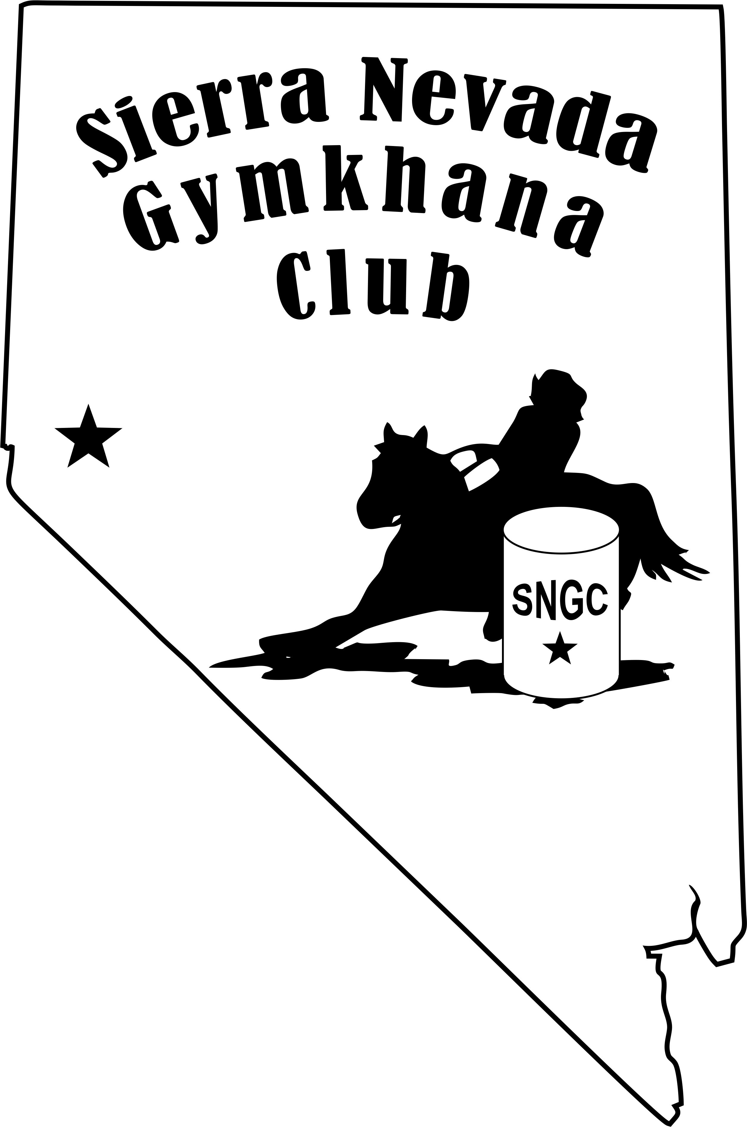

REVISED 2020
SIERRA NEVADA GYMKHANA RULES

2020
SNGC General Rules

- SNGC events are open to all breeds, including mules and ponies.

- In order to ride, the regular fees must be paid and riders must follow SNGC rules. Anyone who is disruptive in any way must leave the arena without further refund of entry fees.

- Officials and directors, without exception, have the right to disqualify or refuse entry to any contestant for any actions of misconduct, profanity, harassment of the judge or officials or employees, unruly or out of control animals, or mistreatment or abuse to their horses or livestock. In club meetings, social media email communication any rude/disrespectful comments and/or blatantly unkind comments will result in one warning. If a second offense occurs, the member(s) can be identified as a member(s) not in good standing. Spectators may be ejected from the grounds. Intoxicated contestants will be disqualified and entry fees will not be refunded.

- Anyone who bounces a check will have to pay cash to cover the check plus any returned item fees before he/she will be allowed to compete and earn further points. For the rest of the season, he/she will have to pay in cash only. Any accounts not in good standing will forfeit year end points and awards will be void.

- No lame horse will be permitted to compete under any circumstance. Any director or official who observes a lame horse should advise the competitor of such.

- If a contestant’s horse is injured or becomes lame over the course of the event, and the competitor voluntarily withdraws the horse from the remaining events, a refund of fees for the remaining events shall be given and the accumulated points will stand.

- Should the competitor disagree with the official, a minimum of three Directors will be called to observe the suspected lameness. The competitor must submit the horse for examination by moving the horse to a trot, if necessary to determine whether the horse is lame. Refusal to comply shall result in immediate disqualification for the day. If the majority of the directors agree that the horse is lame, the horse will be disqualified for the day.

- If a horse has visible signs of illness for example lacerations, runny nose, saliva from mouth or any other visible signs of illness or injury. A Director may ask that the rider leave premises with the horse until it is vet checked or showing no signs of illness or injury.

- Should the contestant disagree with the decision of the Directors, he/she may choose a licensed veterinarian, and call him/her to the arena at his/her own expense. If the veterinarian(s) opinion is that the horse is sound and able to compete without drugs, the horse will be reinstated to the remaining events. Otherwise, the disqualification will stand.

- Horse drugging to disguise lameness or to tranquilize is a violation of the horse-drugging act and is prohibited. Such an act will result in immediate disqualification and entry fees will not be refunded.

- No form of excessive whipping or spurring. No striking of the horse in the head will be allowed. Contestant or guest will be warned once and disqualified for the rest of the day’s events without refund if subsequent infraction occurs.

- Horses entering the arena gate must be at a collected gait, not running, and enter safely. Starting the run before entering the gate is prohibited. Arena director has discretion as to if a contestant is purposely charging a gate. One warning will be given. On the next occasion of the same offense, disqualification from that event will occur.

- Stallions are allowed for senior riders only. Senior riders are those 18-years and older. Stallions must be under control at all times, inside and outside the arena. Any Stallion felt to be jeopardizing the safety of others will be asked to leave without refund of entry fees. No mares with colt at their side will be allowed to compete

- The same horse cannot be ridden by a different rider in the gymkhanas, except for the 7 & under age group who will be allowed to use a horse that is ridden by another member

- No running of horses will be allowed outside the arena, except in a designated warm up arena. Violators will receive one warning from an official. If he/she continues disobeying this rule, disqualification from the next class entered without refund of entry fees will result.

- Horses must be kept away from the snack bar area, this is a health code violation. Repeated violation of this rule is also reason for dismissal from the arena grounds.

- Dogs must be on a leash at all times and are not allowed to disrupt the Gymkhanas. All dogs will be restricted to the vehicle and the trailer area. If a dog becomes aggressive to a person or another animal, the owner will be asked to remove the dog from arena and will not be allowed to return.

- A. Contestants must wear western boots, long pants, long sleeve, short sleeve, or sleeveless shirts. No western tennis shoes allowed. Shirt straps must be at least two fingers wide.

- Any appropriate, neat, humane western equipment may be used. Equipment must be of normal construction. Normal stirrup leathers must be present, of usable length and not tied. Tie down is optional. Unusual construction or arrangements may result in disqualification of the rider if considered by Gymkhana officials to be inhumane, abnormal or dangerous.

- Any contestant can protest. Contestants under 18-years of age must have a parent or guardian present at the time of protest. Protests must be done prior to next event, or at the majority of director’s discretion.

- The course must be run in accordance with the prescribed pattern or disqualification will occur. (This includes the break of forward motion; this is not the same as break of pattern).

- No open containers of alcohol allowed at gates or in the arena.

- For Age Group 0-7 A horse is on course when any part of the horse crosses the start/finish line. If a rider goes off course, but corrects the course, and completes the prescribed pattern, without re-crossing the timing line until the course is completed there will be no disqualification or penalty, Loss of forward motion will not be a penalty for the 0-7 age group.

- 0-7 Lead liners will be part of the 0-7 group however certain added rules will apply as follows: if rider is assisted by a handler, that handler may lead the rider through the course on foot at a WALK OR TROT ONLY. Handler must be at the horse’s shoulder when passing through the timing line. Handlers must be 18 or over in age
- Definition of “assisted” shall be any contestant that is escorted, lead, walked next too or held by a handler that crosses the start finish line. Handlers assisting must be 18 or over.
If the contestant is being lead lined or assisted the handler must stay at the shoulder of the horse from start to finish.

- Definition of “independent” A rider that crosses the start finish line on their own and completes the pattern without the assistance of a handler. Rider may have an adult in the arena, but adult may NOT cross the start/finish line or contestant will be considered an “assisted” lead-liner and shall be scored as such. If your child signs up at the beginning of the year as an lead-liner he/she may advance to riding unassisted and all point accumulated as a lead-liner will remain with rider and vice versa.
- All 0-7 independent riders will be pointed above assisted riders until such time they are unassisted.
- Loss of control will result in disqualification. Falling off horse while on course. Unruly horse; the rider must be in control of horse at all times, if the opinion of the official has determined, the safety of the rider or others might be in jeopardy.
24-A. The contestant will be given one warning then upon second occurrence will be disqualified.

- Knocking down or touching obstacles: Knocking down any obstacle (barrels, pole, etc) shall result in a five (5) second penalty for each obstacle, however, touching an obstacle with the intent of keeping it from going down will not result in a penalty

- Failure to complete course: A contestant shall be disqualified if problems resulting from loss or breakage of equipment or tack prevents completion of the course.

- At least two stopwatches or an electronic timer will be used. If stopwatches are used, the times will be averaged

- Contestants must enter the arena gate within ONE minute after being called and shall be allowed 30-seconds to cross the starting line or disqualification will occur. If there is a legitimate reason (for example breakage of tack, conflict with arenas) for not being at the gate within one minute must be brought to attention of gate person and/or timers or arena director. This rule will be strictly enforced.

- All contestants must be mounted when entering the arena gate for their call. Riders shall not mount their horses inside the arena. If it becomes a safety issue the arena director may allow the rider to walk in the arena and mount their horse, or enter from an alternative gate. Any helper leading a rider on horseback into the arena, or otherwise assisting a contestant in to the arena must leave the arena before the run begin.

- Reruns will not be given for breakage of tack or gear or for any accident of horse or rider. In case of administrative error, reruns will be authorized

- Anyone who bounces a check will have to pay cash to cover the check plus any returned item fees before he/she will be allowed to compete and earn further points. For the rest of the season, he/she will have to pay in cash only. Any accounts not in good standing will forfeit year end points and awards will be void.

- In order to ride, the regular fees must be paid and riders must follow SNGC rules. Anyone who is disruptive in any way must leave the arena without further refund of entry fees.

POINTS

- Classes are open to anyone, but only members will receive SNGC points towards year-end awards. Points will begin to accumulate upon payment of dues and they are not retroactive. A new membership application must be filled out and paid each year.

- Points go to the horse/rider combination. Only one horse can be claimed towards year-end and day-end awards. The horse that will be your point horse must be claimed at the beginning of the season. Only the designated point horse will receive points for year-end and day-end awards. The first place winner receives one point for each contestant in the class. Second place receives one point less than first; third place one point less than second, and so on. A broken pattern or no time will always receive 0 points. There is no removal of non-member point tallies. BEST FIVE OUT OF SIX QUAILIFING POINT GYMKHANNA’S COUNT TOWARD OVER-ALLYEAR END POINTS. Goat tying/un-decorating, Jackpot and Open classes do not count toward day-end or year-end points, but will be awarded a prize at year-end for top money winner in Jackpot classes and top point winner in the Goat and Open classes.

- Hardship applies in cases where the points that are accumulated on the horse can be transferred in the instance that the horse can no longer participate in the current season. These include, but are not limited to, illness (jeopardizing the health of other horses), death or disability. Points will be transferred once to a backup horse, with a veterinarian’s certificate stating the originally declared horse is unable to compete and the diagnosis, and with approval of the majority of the board. A letter must accompany vet outs from the contestant declaring backup horse for approval by board the vet out letter may be emailed to snjrandsngc@gmail.com. Vet outs must be received on or before first Gymkhana following use of backup horse or 30-days, whichever comes first. Use of backup horse must be brought to the attention of the point secretary before the fact. If vetted point horse does not return after veterinarian release date then said backup horse will become primary horse. There will be no swapping between point and backup horse.

- All contestants in an approved class will receive points toward day-end prize and year-end awards based upon their placing in their classes. Members must compete in at least the same four of the five events, and in at least four gymkhanas to be eligible for year-end awards.

- Disturbing the timers or announcers will result in one warning, and if continued, will then result in a loss of day-end points.

- Points from Gymkhana’s will be published on SNGC Official Web Site, www.sngc-snjr.info Any discrepancies must be reported in writing to the SNGC point secretary or SNGC secretary before the next Gymkhana. If no discrepancies are reported, the points will stand as published.

- All contestants in an approved class will receive points toward day-end prize and year-end awards based upon their placing in their classes. Members must compete in at least the same four of the five events, and in at least four gymkhanas to be eligible for year-end awards.

- There must be a minimum of 5 contestants in an age group for a saddle to be awarded; Status of each age group will be determined at the second point gymkhana of the season. Any age groups with less than 5 contestants in an age group a requirement of donors or sponsors will need to be obtained by each contestant in that age group. Board of directors will determine dollar amount of sponsorships or merging into another age group..

AGE DIVISIONS

7 AND UNDER

8 THROUGH 10-YEARS

11 THROUGH 13-YEARS

14 THROUGH 17-YEARS

18 AND OVER

(AGE IS DETERMINED BY YOUR “AGE” AS OF JANUARY1ST)

DAY-END AWARDS

- Color-coded event plates will be given in each class specified to receive event plates for the first through sixth places. Every participant will receive an event placement plate or participant plate.

- Points are awarded in each qualified day-end point class, regardless of whether you place or not, unless you receive a no time, A high point day-end champion and reserve champion will be determined in each of the age groups, by totaling all the day-end point classes on a horse/rider combination. To be eligible for champion and Reserve Champion, the horse/rider combination must compete in at least four of the days point classes. Classes not eligible for day-end awards are the Jackpot, Open, Goat Tying and Goat Un-decorating. Any competitor can compete for day end awards, members only can qualify for year-end awards
YEAR-END AWARDS

- Participation awards will be given to all members who compete in at least (4) Gymkhanas and at least the same four of the five point classes. Awards will only be given to members who fulfill their required membership obligations.

- Individual class awards will be awarded to all members who place in their age groups. To be eligible for an individual class award, you must have competed in the class at least four times during the season.

- A Champion and Reserve Champion award for each age group will be given based on the highest and second highest points on a horse/rider combination with the most accumulated points throughout the year.

- A most improved rider trophy will be awarded at the end of the year. This award will be given to the rider who has been nominated and voted upon as the most improved rider, improving from the first Gymkhana to the last Gymkhana of the season. Improvement of the rider’s ability to control the animal and make the horse perform at its best is the most important qualification of this award. The contestants make nominations and Directors will vote on all nominations. SOLICITING MEMBERS FOR VOTES WILL RESULT IN DISQUALIFICATION.

- Most improved Horse. This horse has greatly improved his/her performance and times from the 1st Gymkhana to the last. The Directors will vote on all nominations. SOLICITING MEMBERS FOR VOTES WILL RESULT IN DISQUALIFICATION.

- SNGC Junior and Senior Sportsmanship awards will be given at the end of the year. This award will be nominated by members and voted on by the membership. Only participants are eligible. Good sportsmanship consists of always helping others, cheering your competitors on, congratulating winners and losers for good runs and always having a cheerful disposition. The Junior Award is for those 17 and under and the Senior Award is for those 18 and over. SOLICITING MEMBERS FOR VOTES WILL RESULT IN DISQUALIFICATION.

- Fastest and Reserve fastest times will be awarded to the winners of said times without bias to the amount of fastest or reserve fastest times they hold.

CLASSES

Regular Classes – The regular classes at each Gymkhana shall consist of Barrels, Poles, Bi-rangle, Figure 8, and Revolving. Regular classes will be at every Gymkhana.

Revolving Classes – At each Gymkhana, there will be one revolving event. Revolving classes consist of Single Stake, keyhole, Speed Barrels, Speed Ball, Flags, Quadrangle, Big “T”. Side Winder, Key Race. Revolving event will be selected at the beginning of the season.

Goat Classes – When stock is available, goat tying and goat un-decorating will be offered.

Goat Tying Rules:

- Time Limit: One Minute

- Starting line will be one hundred (100) feet from the tethering stake.

- Contestant leaves score line with a running start, races to the goat tethered on a 10’ rope, dismounts, throws goat by hand and crosses any three feet for the tie.
  - Contestant may go down rope.
  - If goat is down, it must be brought to its feet and then thrown.
  - Pigging string or leather thong, or rope may be used to tie: no other type of material will be permitted.
  - Goats cannot be dropped from shoulder height to render them breathless and immobile.
  - Unusual roughness in handling goat will disqualify contestant.
  - Contestant will be given a 10-second penalty if horse touches goat or tether rope before or during dismounting.
  - Goat must be held (by official) facing start line, at furthest point away from contestant and must be released as starting flag drops.

- When tie is completed, contestant signals time by throwing both hands in the air.

- Tie must hold for five (6) seconds after contestant has cleared goat.
  - Contestant cannot touch tie or goat after signaling a complete tie.
  - If tie comes loose or if the goat gets to its feet before time has been ruled fair, contestant will be marked a no time.
  - If goat breaks away because of faulty equipment the contestant will be given a re-run at the end of the event.

- The event Director will determine goat changes.

- No distracting goat with movement or sound or disqualification will occur.

Goat Un-decorating:

- Contestant must be 7 or under.
  - Contestant may have helpers.
  - Contestant may have help in dismounting, but helper may not touch goat or goat rope or contestant will be disqualified.

- All goat-tying rules will apply, except goat will be undecorated instead of tied.
  - Goat must have bright colored ribbon tied to its tail.
  - Contestant must remove all of the ribbon from the goat’s tail and throw hands into air to stop time.

JACKPOT PAYOUT %

Awards: Club will hold 60% of purse, 40% of purse goes to the pot
BARREL RACES: To be determined by promoter or sanctions of promoter.

GYMKHANA PATTERNS
If contestant does not understand these patterns it is their responsibility to ask a director before they make their run.

POLE BENDING

Start

21’ feet from time line & between each pole
21’

Run through the starting line, run along either side of the poles to the last pole, turn around the last pole, pass successive poles on alternate sides, turn around the last pole and race back to the starting line. Spacing of poles is 21’ apart and the start finish is 21’ to the first pole.

CLOVERLEAF BARREL RACE

105’

Start
60’ 90’

105’

Cross start/finish line, may start on either side right or left barrel. When starting on the right barrel, there will be one right turn around the barrel and two left turns. When starting on the left barrel, there will be one left turn and two right turns around the barrels. When completing the third barrel, run back through the start/finish line.

FIGURE 8 STAKE RACE

125’

20’

1.Contestant must make one right and one left turn or vice versa. Contestant must close
or complete the eight to receive a time. There are two legal patterns for this event.
2. Contestant runs straight down to the first pole and turns left. The second pole is turned
to the right and then contestant must cross back over to the right side of the first pole in
order to complete the eight.
3. Contestant runs straight down to the first pole and turns right. The second pole is
turned to the left and then contestant must cross back over to the left side of the first pole
in order to complete the eight.
4. Contestant crosses over to other side of first pole from where they started. The first
pole is turned to the left. The second pole is turned to the right and then contestant must
cross back over to the right side of the first pole in order to complete the eight.
5. Contestant crosses over to other side of first pole from where they started. The first
pole is turned to the right. The second pole is turned to the left and then contestant must

cross back over to the left side of the first pole in order to complete the eight.

BI-RANGLE STAKE RACE

75’

37.5’

20’ Start line

Run through the timing line, turn poles in the same direction ether left or right. Pass back through the timing line.

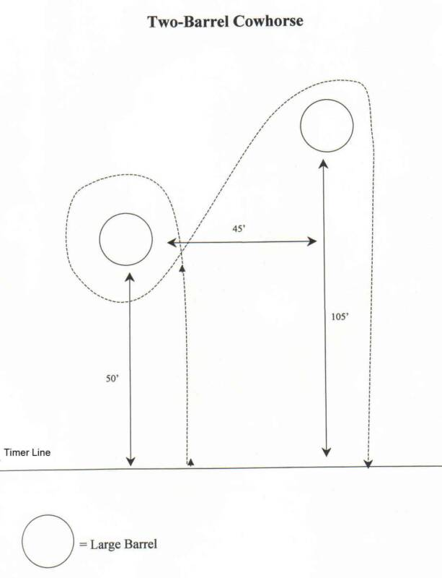

Go across the timer line and go on inside of left barrel go around and then to the outside of far barrel and back to the timer line.

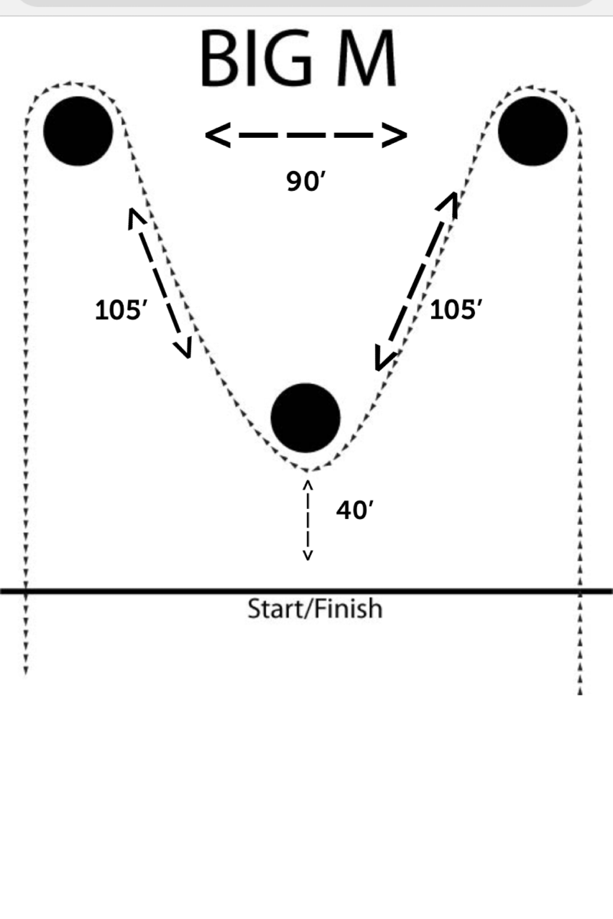

You can go either to the far right or far left barrel first, make and M with all 3 barrels.

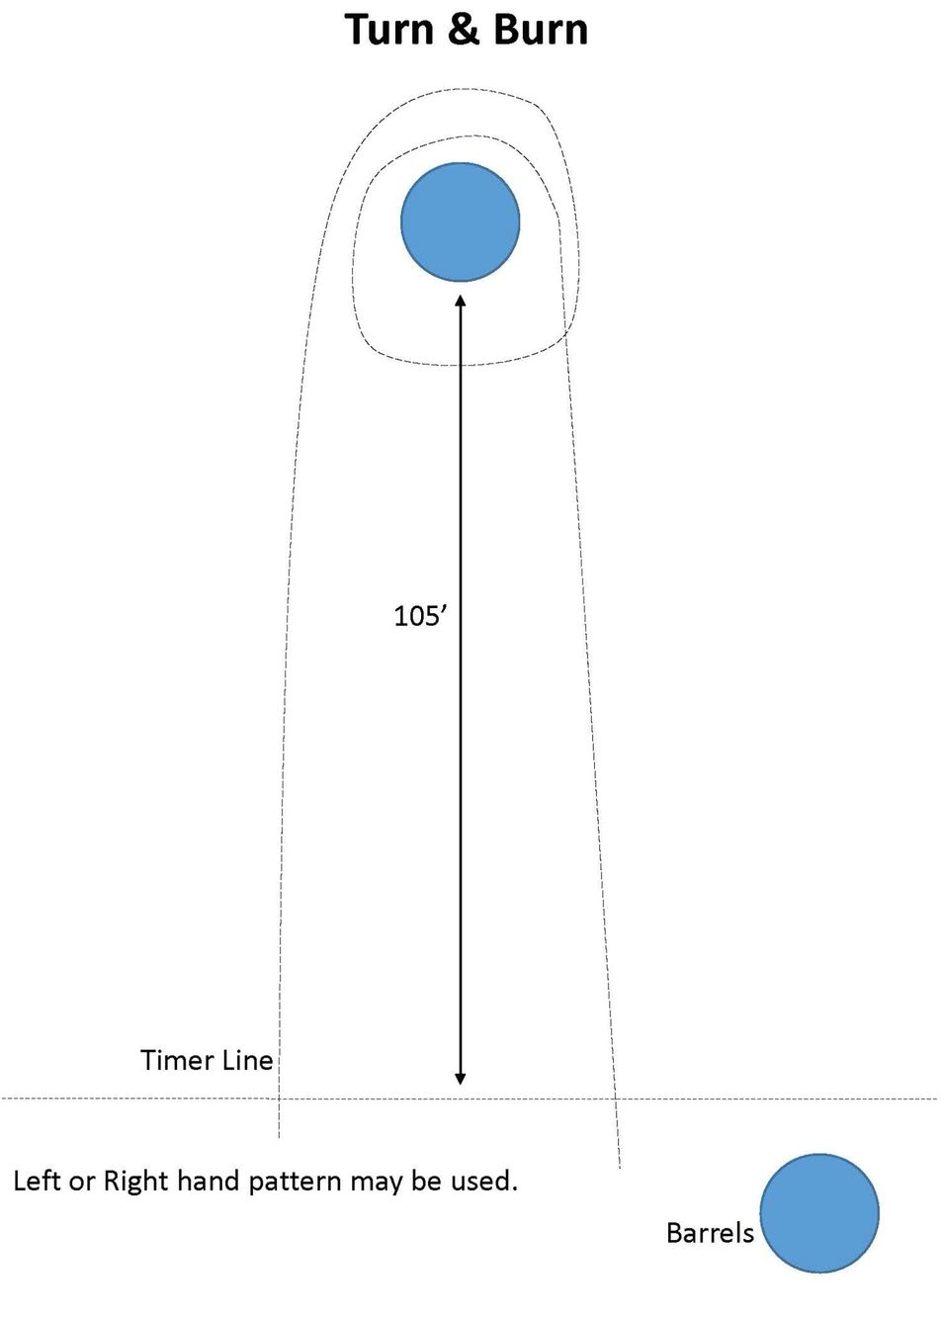

You may to the left or right make a full circle around barrel and back across timer.

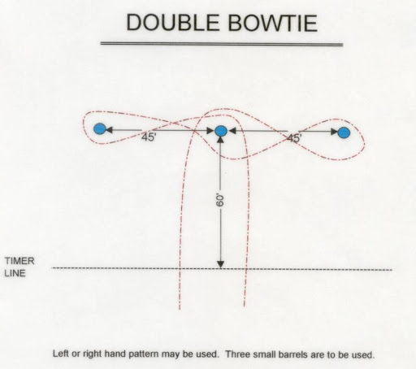

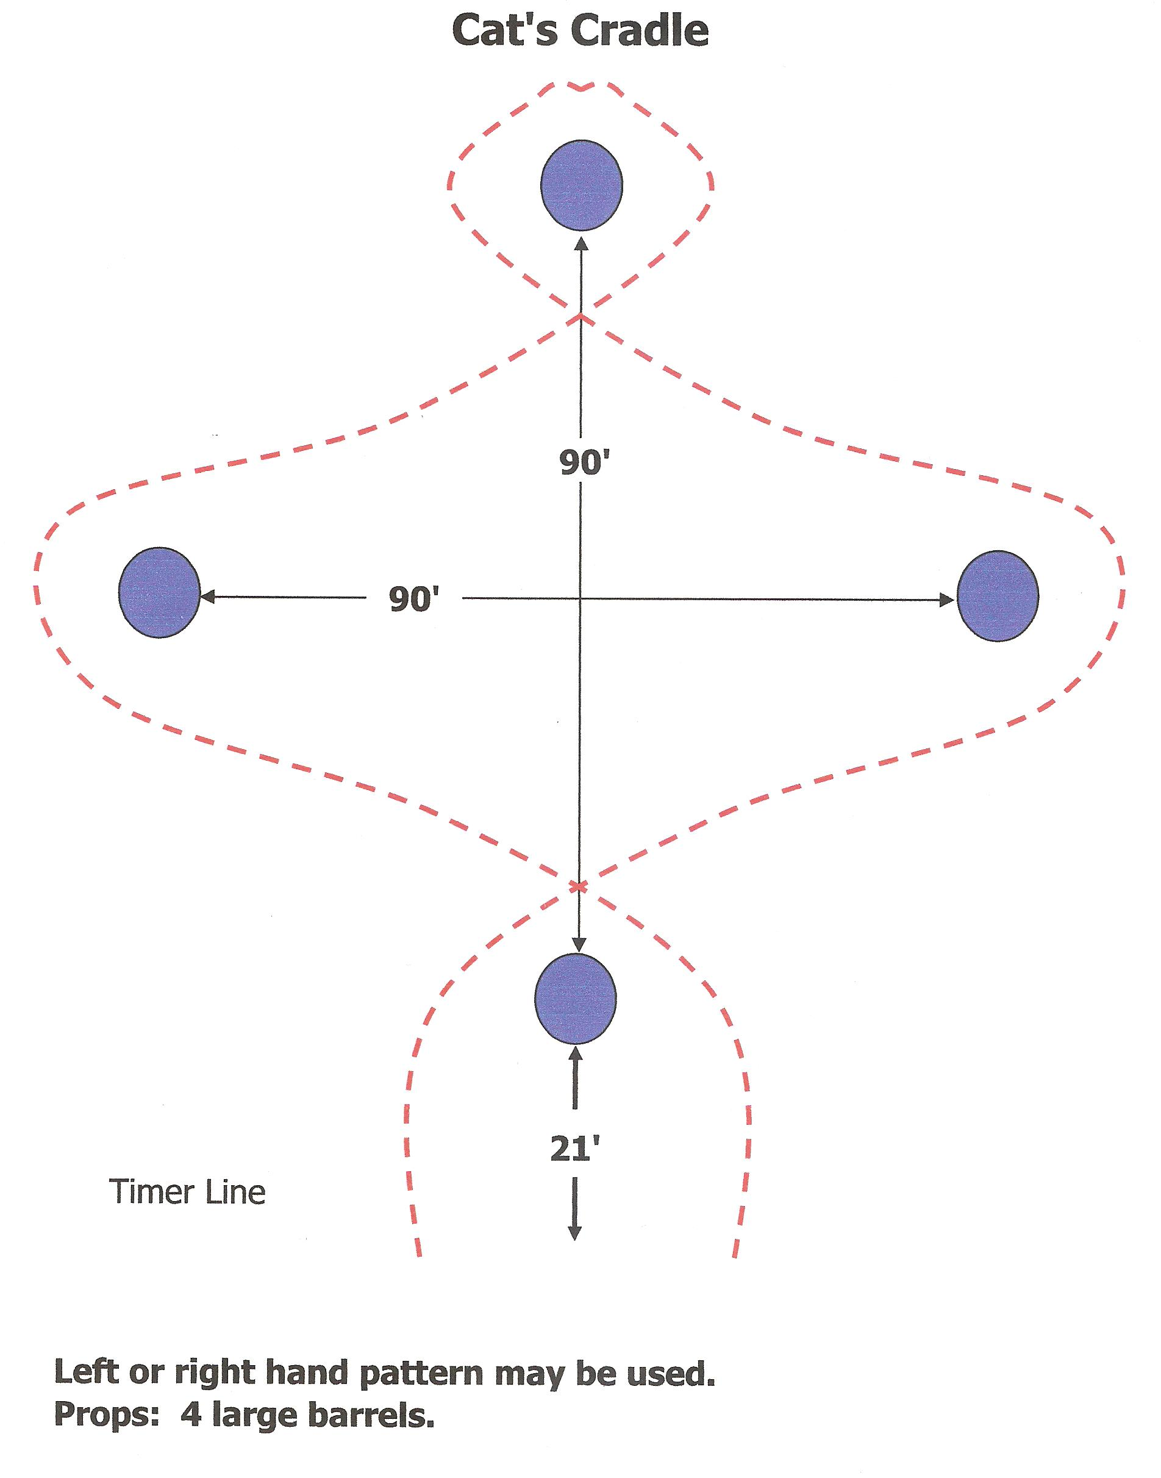

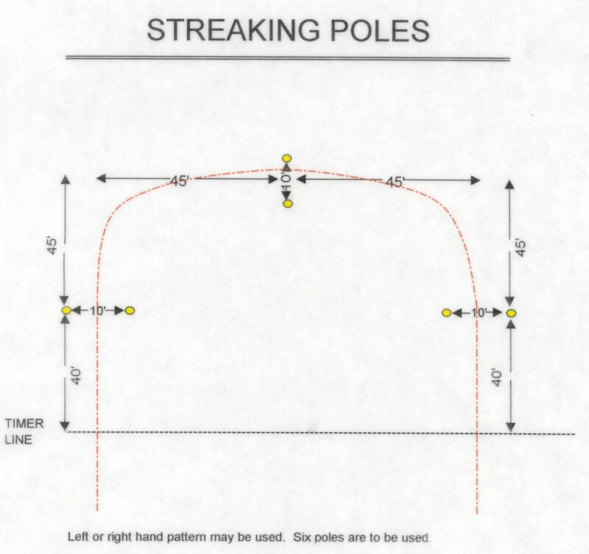

CHECK LIST

Please return the following forms at Play-Day or prior to the first Gymkhana. Remember…you will not accumulate points until you have paid your membership fee and turned in the necessary forms:

- Signed Membership Form
- Signed Membership Rules
- Release Form
- Point Horse Form
- Copy of birth certificate for those under 18

Forms which need to be turned in prior to September Gymkhana
(these will be handed out at the Gymkhana later in the season)

- Participant Wish List
- Awards Nominations (Most improved Rider and Most Improved Horse. Senior and Junior sportsman ship).

Lost your Forms!! No worries go to: www.sngc-snjr.info

You are always welcome to mail any of the above forms to:

SNGC
PO Box 60674
Reno, NV 89506

Also, if you have questions, please do not hesitate to contact any one of the Officers or Directors on your list. They will be happy to offer their assistance.

**Don’t forget about Pre-Registration for all Gymkhanas**

INDIVIDUAL
Membership Information/Application

There are three types of individual memberships available: General Individual, General non-competing and Associate Individual Membership. To maintain your General Membership status, you must fulfill your volunteer requirements as outlined in the Membership Information section of this Application. Volunteer/fundraising status is reviewed the first week of August and you will be notified of your standing. (Volunteer/Fundraising Requirements must be met by the last gymkhana or ALL General Memberships will be converted to an “Associate” Membership and the difference in fees will be due and payable immediately. Any outstanding fees not paid will cause you to become a Member NOT in good standing and will make you ineligible for Year End Awards.)

Please Check the Membership you wish to select:

General Individual Membership ($75) ________________
PLUS 15 raffle ticket sales or donation of equivalent value
General non-Competing ($50) _______________
PLUS 15 raffle ticket sales or donation of equivalent value
Associate Individual Membership ($350) ________________
(No Volunteer/Fundraising Jobs Required/No Voting Privileges)

Individual Name: _____________________________________________________

Address: _________________________________________________________________

City: ________________ State: ___________________ Zip:__________

Phone Number ( ) ___________________ DOB:______________________

Email Address: ______________________________________________________

Point Horses Name: _____________________color/breed____________________
(Please read rule book for detailed description and rules pertaining to Point Horses).

A monthly newsletter will be emailed to each member please provide the best Email address
Email To: ___________________________ _

I agree to read and abide by the SNGC/SNJR rules; I also acknowledge receiving my MEMBER INFORMATION PACKET.

____________________________________________________ ________________________
Signature Date
BIRTH CERTIFICATE MUST BE TURNED IN WITH APP OR BY SECOND POINTS GYMKHANNA
Office Use Only: Amt Paid ______Cash_____Check_____Date_______ Rec’d By:_______

FAMILY
Membership Information/Application

There are two types of FAMILY memberships available: General Family and Associate Family Membership. To maintain your General Membership status, you must fulfill your volunteer requirements as outlined in the Membership Information section of this Application. Volunteer/fundraising status is reviewed the first week of August and you will be notified of your standing. (Volunteer/Fundraising Requirements must be met by the last gymkhana or ALL General Memberships will be converted to an “Associate” Memberships and the difference in fees will be due and payable immediately. Any outstanding fees not paid will cause you to become a Member NOT in good standing and will make you ineligible for Year End Awards.)

General Family Membership ($150) ________________
(Family must be immediate family in the same household, Children must be 18 or under)
PLUS 25 raffle ticket sales or donation of equivalent value
Associate Family Membership ($525) ________________
(No Volunteer/Fundraising Jobs Required/No Voting Privileges)

Family/ Name: ____________________________________________________ _

Address: _________________________________________________________________

City: _____________________________ State: ___________________ Zip:__________

Phone Number ( ) _________________Email Address: ______________ ________

Contestant Name: ________________________________ DOB:___________

Point Horses Name: _____________________color/breed____________________

Contestant Name: __________________________________________DOB:________ __

Point Horses Name: _____________________color/breed____________________

Contestant Name: ________________________________ DOB:____________

Point Horses Name: _____________________color/breed____________________

(Please read rulebook for detailed description and rules pertaining to Point Horses).
Use back for additional family members

A monthly newsletter will be emailed for each membership please provide the best email address for the newsletter.

Email To: ___________________________ _
I/we agree to read and abide by the SNGC/SNJR rules, I also acknowledge receiving my MEMBER INFORMATION PACKET.
____________________________________________________ ________________________
Signature Date
BIRTH CERTIFICATE MUST BE TURNED IN WITH APP OR BY SECOND POINTS GYMKHANNA
Office Use Only: Amt Paid ______Cash_____Check_____Date_______ Rec’d By:_______

2020 Point Horse

Your point horse is the horse you will be competing on and the horse you will gain your points with. Points go to the horse/rider combination. Only one horse can be claimed towards year-end. The horse that will be your point horse must be claimed at the beginning of the season.

Photo plate plaques available. These plaques hold your day-end plates. Please check one. If you choose yes to ordering a plaque, please complete he separate form (page 30)

PLATE PLAQUE $15.00 YES______ NO______

Please Print Clearly

Contestant Name: _________________________

Age Group: ____________________

Point Horse Name: _______________________________

COLOR/BREED_____________________________________________

YOU MUST TURN THIS FORM IN TO START ACCUMULATING POINTS
ONE FORM FOR EACH HORSE & RIDER.

Office Use Only: Amt Paid ______Cash_____Check_____Date_______ Rec’d By:_______

Sierra Nevada Junior Rodeo / Gymkhana Club Assumption of Risk, Waiver and Release of liability, and Indemnification Agreement

This document shall be enforced to the greatest extent permitted by law. If any clause of this document conflicts, with applicable law, only that clause will be null and void but the remainder shall stay in full force and effect. Should a contestant, parent or legal guardian of a minor contestant file a lawsuit in breach of this document agree to pay all attorney fees, court costs, and other costs incurred by Sierra Nevada Junior Rodeo/Gymkhana Club.

Herein, these terms listed below will be referred or written:
- Sierra Nevada Junior Rodeo/Gymkhana Club----SNJR/SNGC
- Contestant--- Will include the minor contestant’s parent or legal guardian
- Sierra Nevada Junior Rodeo/Gymkhana Club events----Event

Contestant agrees to the following:
- Inherent Risks of Equine Activities/Assumption of Risks: Contestant acknowledges that there are numerous inherent risks of equine activities, whether preparing for, entering, attending, participating in, or leaving the Events. This inherent risks include these dangers and conditions which are an integral part of equine activities, including but not limited to: (a) the propensity of an equine or other animals to behave in ways that may result in injury, harm or death to persons on or around them (b) the unpredictability of the equines’ reaction to such things as sounds, sudden movements, and unfamiliar objects, persons, or other animals; (c) certain hazards such as surface or subsurface conditions: (d) collisions with other animals or objects; (e) the potential of a participant or other contestant to act in a negligent manner that may contribute to injury to the participant, contestant, or others, such as failing to maintain control over the equine or not act within his or hers ability (f) the breakage or failure of tack or other equipment: and (g) the potential that an equine or animal may suffer
an injury or lose its footing or balance resulting in a fall or other movement that causes injury or harm to the rider or other persons or animals in the vicinity.
Contestant is not relying on SNJR/SNGC to list all possible inherent risks or all risks of participating in equine events.

- Waiver and Release of Liability: With full knowledge and appreciation of these inherent risks of equine activities, Contestant freely and voluntarily assumes the risks of the equine activities involved in any aspect of the Event. In this connection, Contestant so voluntarily agrees to waive any and all rights to sue and hereby releases SNJR/SNGC from all liability, loss, claims, or actions for injury, death, expenses, or damage to person or property resulting from the inherit risks of the event, or resulting from any action or inaction of SNJR/SNGC. This waiver and release shall be effective even if the injury, death, or damage to a person or property is caused by or contributed to by actions of failure to Contestant nor contestants representatives shall make any claim against, maintain an action against, or recover from the Event or its sponsors, promoters, producers, directors, officers, employees, agents, volunteers, representatives, designated officials, or other acting on their behalf for injury, loss, damage or death of the Contestant or to the contestant’s horse or personal property. (Regardless of whether the SNJR/SNGC was negligent or somehow violated an applicable law pertaining to equine activities.)

- Indemnification: contestant, or parent or legal guardians of the undersigned minor, hereby agrees to indemnify and hold harmless the SNJR/SNGC from any liability, claim, loss, action or expenses asserted or incurred by the Event for damages arising out of the actions or inactions of the Contestant and Contestant’s employees, agents, representatives, trainers, animals, independent contractors, or other acting on their behalf. The term “expenses” shall include, but not limited to, attorney fees, court costs, investigations costs, and other expenses incurred in the defense of any matter asserted which may be covered by this indemnification provision.

- Compliance With the Sierra Nevada Gymkhana Club Rule Book: Contestants understands and agrees that entry to any sanctioned Events shall constitute an agreement that the contestant, (including the horse owner, lessee, trainer, coach, rider, and the horse), shall be subject to the Sierra Nevada Gymkhana Club rule Book. Any disputes between the contestant and Sierra Nevada Gymkhana Club in regards to the Event shall be governed by the Rule Book specific to the Event. A Contestant’s sole and complete remedy for any dispute is an appeal to the proper appellate body, committee, as identified for such disputes in the Sierra Nevada Gymkhana Club Rule Book.

- Use of Photographs or Videos: Contestant herby irrevocably grants full permission for the SNJR/SNGC, to use and publish photographs, videos or movies taken of the Contestant at the Event, even if such use and publication is for commercial or promotional purposes.

I have read this document, Assumption of Risk, Waiver and Release of Liability and Indemnification. I the contestant, the parent or the legal guardian of the contestant freely and voluntarily seeking participation at and SNJR/SNGC Event. Contestants appreciate and assume all risks inherent in any SNJR/SNGC event and understand this document is a release of claims and agree to be fully bound by its terms

Contestant’s Name____________________________________________

Age Group:__________________________

Release: I ____________________________________, the contestant, the contestant’s parent or legal guardian, do hereby release the Sierra Nevada Junior Rodeo/Gymkhana Club, or its sponsors, promoters, directors, officers, employees, agents, volunteers, representatives, designated officials. Or others, acting on their behalf from any and all responsibility and liability for any and all injuries or disablements of any kind whatsoever, suffered or inflicted at any Sierra Nevada Junior Rodeo/Sierra Nevada Gymkhana Club event. I have the Assumption Of Risk, Waiver and Release of Liability, And Indemnification Agreement, I understand it and agree to be fully bound by its terms.

Date_________________________________

Signed____________________________________________________________

2020 SNGC General Rules

I, the undersigned, acknowledge receipt of the written 2020 SNGC General Rules. By signing below, I certify that I have read and understand the contents of these General Rules. Further, I agree to abide by these rules as written. I understand that failure to abide by these general rules could result in a forfeiture of any points earned, disqualification or termination of my membership (where applicable).
Please print Member name and Sign. If Member is under 18-years old, both member and parent/legal guardian must sign.
Please Print Name then Sign

Individual/Family Name: _____________________________________________________

Contestant_________________________________________________________________

SIGNATURE _________________________________________________________________

Contestant_________________________________________________________________

SIGNATURE _________________________________________________________________

Contestant_________________________________________________________________

SIGNATURE _________________________________________________________________

Contestant_________________________________________________________________

SIGNATURE _________________________________________________________________

GUARDIAN_________________________________________________________________
This form is part of your Membership Package, and as such, must be completed and turned in before points can begin to be accumulated.

50/50 RAFFLE SALES

THE SALE OF THE 50/50 RAFFLE TICKETS HAS HISTORICALLY BEEN A SUCCUSFUL FUND RAISING EVENT IN WHICH THE FUNDS GENERATED FROM SALES ARE USED TOWARD AWARDS FOR JUNIOR RODEO AND GYMKHANA END OF YEAR AWARDS. EACH TICKET SOLD WILL CONSTITUTE 1 POINT TOWARD VOLUNTEER REQUIREMENTS. EACH NON COMPETING MEMBER WILL BE GIVEN 10 TICKETS TO SELL, INDIVIDUAL MEMBER WILL BE GIVEN 15 TICKETS TO SELL AND FAMILY MEMBERSHIPS WILL BE GIVEN 25 TICKETS TO SELL AT THE 2018 MEMBERSHIP DRIVE/PLAYDAY OR FIRST GYMKHANA OF THE SEASON. ADDITIONAL TICKETS WILL BE AVAILABLE UPON REQUEST. ANY UNSOLD TICKETS AND MONEY MUST BE TURNED IN AND ACCOUNTED FOR AT THE GYMKHANA IMMEDIATELY PRIOR TO SIERRA NEVADA JUNIOR RODEO IN JULY.

$$$$$$$$$$$$$$$$$$$$$$$$$$$$$$$$$
THREE PRIZES FOR TOP SALES OF RAFFLE TICKETS
#1 Non-competing membership
#1 Individual membership
#1 Family membership
$$$$$$$$$$$$$$$$$$$$$$$$$$$$$$$$$$

NAME_________________________________________________

EMAIL_________________________________

PHONE_______________________________

CIRCLE MEMBERSHIP TYPE: NON-COMPETING INDIVIDUAL FAMILY

2020 PLAQUE ORDER FORM

PLATE PLAQUE $15.00 YES______ NO______

Please Print Clearly

Contestant Name: _________________________

Age Group: ____________________

Point Horse Name: _______________________________

Office Use Only: Amt Paid ______Cash_____Check_____Date_______ Rec’d By:_______

Date plaque ordered _________________

Date plaque given to contestant/contestant representative ___________________

